**NETWORKING & SYSTEM ADMINISTRATION LAB**

**Name: Blessy Sajeev**

**Roll No:44**

**Batch:MCA-A**

**Date:20-03-2022**

**Experiment No.: 1**

**Aim**

Identify major components of a computer system such as

* Motherboard

* RAM modules

* Daughter cards

* Bus slots

* SMPS

* Internal storage device

* Interfacing ports

**Procedure**

**Motherboard:** The motherboard is mounted inside the case and is securely attached via small screws through pre-drilled holes. Motherboard contains ports to connect all of the internal components. It provides a single socket for CPU, whereas for memory, normally one or more slots are available. Motherboards provide ports to attach the floppy drive, hard drive, and optical drives via ribbon cables. Motherboard carries fans and a special port designed for power supply.

There is a peripheral card slot in front of the motherboard using which video cards, sound cards, and other expansion cards can be connected to the motherboard.

On the left side, motherboards carry a number of ports to connect the monitor, printer, mouse, keyboard, speaker, and network cables. Motherboards also provide USB ports, which allow compatible devices to be connected in plug-in/plug-out fashion. For example, pen drive, digital cameras, etc.

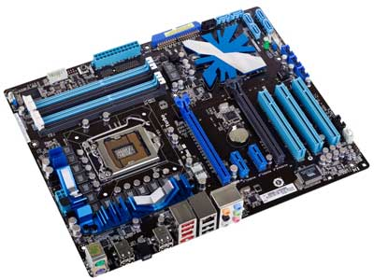

A motherboard comes with following features −

* Motherboard varies greatly in supporting various types of components.
* Motherboard supports a single type of CPU and few types of memories.
* Video cards, hard disks, sound cards have to be compatible with the motherboard to function properly.
* Motherboards, cases, and power supplies must be compatible to work properly together.

**RAM Modules:** In computing, a **memory module** or **RAM (random-access memory) stick** is a printed circuit board on which memory integrated circuits are mounted. Memory modules permit easy installation and replacement in electronic systems, especially computers such as personal computer, workstation, and servers. The first memory modules were proprietary designs that were specific to a model of computer from a specific manufacturer. Later, memory modules were standardized by organizations such as JEDEC and could be used in any system designed to use them.

Types of memory module include:

* Trans flash Memory Modules
* SIMM, a single in-line memory module
* DIMM, dual in-line memory module
  + Rambus memory modules are a subset of DIMMs, but are normally referred to as RIMMs
  + S0-DIMM, small outline DIMM, a smaller version of the DIMM, used in laptops

**Daughter card:** A daughterboard (or daughter board , daughter card , or daughtercard ) is a circuit board that plugs into and extends the circuitry of another circuit board. The other circuit board may be the computer's main board (its motherboard ) or it may be another board or card that is already in the computer, often a sound card. The term is commonly used by manufacturers of wavetable daughterboards that attach to existing sound cards.

**Bus Slots:** Alternatively known as bus slot or expansion port, an expansion slot is a connection or port inside a computer on the mother board or riser card. It provides an installation point for a hardware expansion card to be connected. For example, if you wanted to install a new video card in the computer, you’d purchase a video expansion card and install that card into the compatible expansion slot.

*AGP-video card

*AMR-modem, sound card

*CNR-modem, network card, sound card

*EISA-SCSI, network card, video card

**SMPS(Switched-Mode Power Supply):** A switched-mode power supply (SMPS) is an electronic circuit that converts power using switching devices that are turned on and off at high frequencies, and storage components such as inductors or capacitors to supply power when the switching device is in its non-conduction state. Switching power supplies have high efficiency and are widely used in a variety of electronic equipment, including computers and other sensitive equipment requiring stable and efficient power supply. A switched-mode power supply is also known as a switch-mode power supply or switching-mode power supply.

**Internal Storage Devices:** Most computers have some form of internal storage. The most common type of internal storage is the hard disk. At the most basic level, internal storage is needed to hold the operating system so that the computer is able to access the input and output devices. It will also be used to store the applications software that you use and more than likely, the original copies of your data files.

Internal storage allows the data and applications to be loaded very rapidly into memory, ready for use. The data can be accessed much faster than data which is stored on an external storage device. This is because internal storage devices are connected directly to the motherboard and its data bus whereas external devices are connected through a hardware interface such as USB, which means they are considerably slower to access. Internal storage also means that if the computer is moved around, it will still retain its most commonly used data.

The main disadvantage of internal storage is that when the hard disk fails (and it will), all the data and applications may be lost. This can be avoided to some extent by using more than one hard disk within the machine. Each hard disk has a copy of all the data, so if one fails the other can carry on. This is called a RAID array. An alternative is to use external drives for backup.

**Interfacing Port:** A port is a physical docking point using which an external device can be connected to the computer. It can also be programmatic docking point through which information flows from a program to the computer or over the Internet.

**Characteristics of ports:**

* External devices are connected to a computer using cables and ports.
* Ports are slots on the motherboard into which a cable of external device is plugged in.
* Examples of external devices attached via ports are the mouse, keyboard, monitor, microphone, speakers, etc.

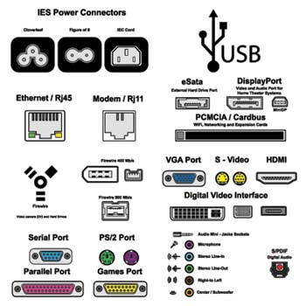

## **Serial Port**

* Used for external modems and older computer mouse
* Two versions: 9 pin, 25 pin model
* Data travels at 115 kilobits per second

## **Parallel Port**

* Used for scanners and printers
* Also called printer port
* 25 pin model
* IEEE 1284-compliant Centronics port

## **PS/2 Port**

* Used for old computer keyboard and mouse
* Also called mouse port
* Most of the old computers provide two PS/2 port, each for the mouse and keyboard
* IEEE 1284-compliant Centronics port

## **Universal Serial Bus (or USB) Port**

* It can connect all kinds of external USB devices such as external hard disk, printer, scanner, mouse, keyboard, etc.
* It was introduced in 1997.
* Most of the computers provide two USB ports as minimum.
* Data travels at 12 megabits per seconds.
* USB compliant devices can get power from a USB port.

## **VGA Port**

* Connects monitor to a computer's video card.
* It has 15 holes.
* Similar to the serial port connector. However, serial port connector has pins, VGA port has holes.

## **Power Connector**

* Three-pronged plug.
* Connects to the computer's power cable that plugs into a power bar or wall socket.

## **Firewire Port**

* Transfers large amount of data at very fast speed.
* Connects camcorders and video equipment to the computer.
* Data travels at 400 to 800 megabits per seconds.
* Invented by Apple.
* It has three variants: 4-Pin FireWire 400 connector, 6-Pin FireWire 400 connector, and 9-Pin FireWire 800 connector.

## **Modem Port**

* Connects a PC's modem to the telephone network.

## **Ethernet Port**

* Connects to a network and high speed Internet.
* Connects the network cable to a computer.
* This port resides on an Ethernet Card.
* Data travels at 10 megabits to 1000 megabits per seconds depending upon the network bandwidth.

## **Game Port**

* Connect a joystick to a PC
* Now replaced by USB

## **Digital Video Interface, DVI port**

* Connects Flat panel LCD monitor to the computer's high-end video graphic cards.
* Very popular among video card manufacturers.

## **Sockets**

* Sockets connect the microphone and speakers to the sound card of the computer.